* -: So how does Angular connect to a database, or how do you connect Angular to a database in your application? Well, of course it is a use case that you will often have.
* In your Angular app you generate data like posts or recipes or whatever you have in your application and you wanna store that data in a database and all the fetches from there when your app restarts, when a user revisits your page, and so on.

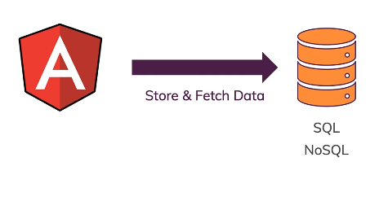

* And it doesn't matter which kind of database we're talking about, if that's a SQL or no SQL database, doesn't really matter.
* The thing is you don't connect Angular to a database directly.
* That means you don't enter your database credentials into your Angular app or anything like that.
* This would be highly insecure because everyone can read your Angular code.
* Since it's a frontend JavaScript application, everyone can inspect the code there, and that is fine, but that also means you must not store credentials in there, for example.
* And you will learn how you can still authenticate users and so on later in the authentication section, but you definitely don't want to store database credentials.
* For more information on how secure your JavaScript code is, you can have a look at an article and a video I attach to this video here.
* So if we don't connect directly to a database, what else can we do then? Because we certainly don't want to have our standalone independent, unconnected Angular app.

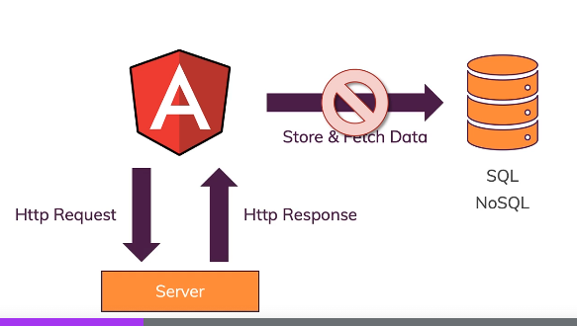

* Well, you send HTTP requests, and you get HTTP responses to and from a server.
* A server, in the end, is defined as an API here.
* That means it is, for example, a REST API or a GraphQL API you are communicating with.
* And in this course, we'll use a REST API, which is the most common form of API you work with.
* Now, such a API in the end is almost like a normal website but when you visit its URLs, you're not getting back HTML, but you're getting back data, mostly in JSON format.
* And if you wanna learn more about REST APIs in general, you also find some helpful resources related to that attached to this video, and I have a whole course, my Note JS course, where I also teach you how to create such APIs.
* Because you don't use Angular for the creation of these APIs, you use server side languages like Note JS or PHP instead.
* But you can communicate with these APIs with Angular, and on that server, you then can have code that does interact with a database to store and fetch data.
* And of course, there are more reasons for communicating with a server than for storing or fetching data.
* It's not just about database access.

* You could be uploading files or you could be sending some analytics to a backend or any other reason for why you might need to talk to some backend server.
* Now in this module, we will not write such a backend from scratch since this is way beyond the scope of the course, and totally not Angular's job.
* But I will show you how to use a free dummy backend, which could of course be replaced by any real backend you have, cue send requests to use responses and so on.